Funding Bulletin
October 2025
Information for the bulletin is compiled from a number of sources including Grantfinder, and direct from funders themselves. It showcases just a few of the hundreds of funding opportunities available for local community, voluntary and faith organisations.

Assistance and support is available with putting together your quality funding bid. Please find the details below of who to contact in your area and get in touch to see how we can work with you to help you achieve a successful application.

Contact details for support and further information can be found on the final page.
Please also let us know if you are successful in securing funding as a result of spotting an opportunity in our bulletin!

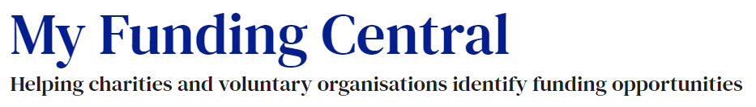
Funding search engine
If you are looking for a funding search engine to help you find funds which may be suitable for your project ideas, we recommend My Funding Central which is a free service for organisations with an income of less than £30,000. For organisations with a higher income, annual subscription starts from only £50.

CONTENTS

ARTS 7
CHILDREN & YOUNG PEOPLE 10
DIGITAL 12
ENVIRONMENT 13
FAITH 16
GENERAL 18
HEALTH & WELLBEING 21
HERITAGE 24
OLDER PEOPLE 27
SPORT & RECREATION 30

LOCAL
Bolton’s Fund |  | 
Aims/priorities: | The funding is intended for projects in six priority areas, identified by Bolton’s Vision 2030 and informed through Bolton’s Joint Strategic Needs Assessment (JSNA), codesigned with communities and community intelligence.  The priority areas are:  - Start Well – giving children the best possible start in life.  - Live Well – improving the happiness and wellbeing of Bolton residents.  - Age Well – helping older people stay connected, active and healthy in their communities.  - Prosperous – supporting enterprise, inclusive employment and maximising social value for Bolton.  - Clean and Green – protecting, improving and enjoying our environment.  - Safe, Strong and Distinctive – creating safe, stronger, cohesive and more confident communities.
Who can apply? | Community groups, charities, and organisations working in Bolton can apply.  The group or organisation must be:  - A constituted voluntary or community group  - A registered charity  - Another type of constituted not for profit organisation.  - If applying for over £5,000, a registered charity or an incorporated not for profit.
Grant amount: | Discretionary
Application process: | For micro-grants and small grants, applications can be submitted at any time until all funding has been allocated.  The next deadlines for medium and partnership grants is 2 November 2025.  Guidelines and seperate online application forms for each grant size are available from the Bolton CVS website.
Deadline: | Rolling Programme
Contact: | funding@boltoncvs.org.uk
Website: | Bolton's Fund - Bolton CVS

Duchy of Lancaster Benevolent Fund |  | 
Aims/priorities: | The Duchy of Lancaster Benevolent Fund offers grants to charitable organisations that are active in Merseyside, Greater Manchester and Lancashire for projects that benefit local communities and residents.  The Trustees are particularly interested in the following:  - Causes with which the Duchy has historical association such as church livings and estates within the boundaries of the three Counties and purposes which will benefit the community.  - Trusts, Associations and Institutions that maintain and preserve monuments, Estates and possessions of the Duchy which prove to be of benefit to the public and local community.  - Organisations which provide care and support for people who are older, infirm or disadvantaged members of society.  - Community Associations that benefit local people.  - Organisations for young people such as Scouts, Guides, Cadets, Youth Organisations etc.  - Support for educational initiatives that will have beneficial results for the local community.
Who can apply? | Applications will be accepted from registered charities and local voluntary and community organisations.  To be eligible, applicants must:  - Operate in Merseyside, Greater Manchester or Lancashire.  - Have a bank account in the organisation's name.  - Demonstrate a clear benefit to the local community.
Grant amount: | £ 2,000
Application process: | Applications may be made at any time in each area: Merseyside, Greater Manchester and Lancashire.  Applications should be submitted to the appropriate office for the applicant's area:  - The Greater Manchester application form is available from the web page of the Greater Manchester Lieutenancy Office and should be submitted by email to accountant@gmlo.org  - Lancashire applications should be made by letter (on headed paper) either by post to the Lancashire Lieutenancy Office or by email to lieutenancy@lancashire.gov.uk  - The Merseyside application form is available from the web page of the Merseyside Lieutenancy Office and should be submitted either by post to the Merseyside Lieutenancy Office or by email to msl.clerk@lieutenancy.info
Deadline: | Rolling Programme
Contact: | Greater Manchester Lieutenancy Office  Duchy of Lancaster Benevolent Fund  Tel: 0161 834 0490  Email: office@gmlo.org  Lancashire Lieutenancy Office  Duchy of Lancaster Benevolent Fund  Email: lieutenancy@lancashire.gov.uk  Merseyside Lieutenancy Office  Duchy of Lancaster Benevolent Fund  Tel: 0151 363 9528  Email: msl.clerk@lieutenancy.info
Website: | Benevolent Fund - Duchy of Lancaster

Forever Manchester |  | 
Aims/priorities: | Objectives of Fund  Forever Manchester helps fund and support a huge range of activities organised by community and grassroots groups in Greater Manchester. Examples of projects that can apply for funding include:  - Working with older residents.  - Working with children and young people.  - Improving health and wellbeing of the local community.  - Encouraging volunteering.  - Starting new community groups.
Who can apply? | Local voluntary and community groups, including grassroots organisations, are eligible to apply.  Only one application per organisation will be accepted.
Grant amount: | Discretionary
Application process: | For more information including opening and closing dates, applicants should contact Forever Manchester to work out their eligibility and find the most suitable fund.  Online application forms are available from the Forever Manchester website.
Deadline: | Rolling Programme
Contact: | awards@forevermanchester.com
Website: | Forever Manchester - Charity

ARTS
Scops Arts Trust |  | 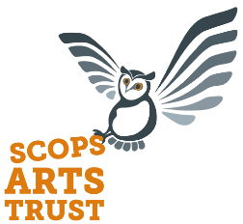
Aims/priorities: | The aim of the Trust is to give people of all ages the opportunities to access, participate in and enjoy the arts (particularly the performing arts), and support projects that widen access and have a lasting cultural impact on local communities.
Who can apply? | The Trust mostly supports registered charities.  Applications will also be considered from social enterprises, community groups, and other third sector organisations, as long as they are formally constituted and have clear charitable purposes.  Priority will be given to small and medium sized organisations.
Grant amount: | Up to £ 30,000
Application process: | The application process is as follows:  - To start the application process, organisations should first take complete the eligibility checks which can be accessed on the Scops Arts Trust website.  - Organisations that fulfill the criteria will be invited to make a Stage 1 online application.  - A Stage 2 shortlist will then be drawn up and the selected applicants will be invited to complete a Stage 2 online application form.
Deadline: | 9th December 2025
Contact: | info@scopsartstrust.org.uk
Website: | Scops Arts Trust - Grant Funding for the Arts

Theatres Trust Small Grants Scheme |  | 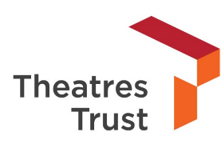
Aims/priorities: | The scheme aims to fund small capital improvements to theatres run by charities and not-for-profit groups that will make a big impact to a theatre's resilience, sustainability or accessibility, or to improving the diversity of audiences.
Who can apply? | To be eligible, applicants must meet the following requirements:  - Own or manage theatres with titles or signed leases of more than five years on buildings in England, Scotland, Wales or Northern Ireland.  - Demonstrate that they run a regular theatre programme of professional, community and/or amateur work presenting no less than 30 performances a year.  - Have a bona fide UK charitable or not-for-profit legal structure and be able to provide certified or audited accounts for at least two years.  The Trust welcomes applications from theatre venues across the UK that meet these criteria, whether voluntarily or professionally run.
Grant amount: | Up to £ 7,500
Application process: | Application forms are available to download from the Theatres Trust's website.
Deadline: | 16 January 2026 (5pm)
Contact: | grants@theatrestrust.org.uk
Website: | Small Grants Programme supported by The Linbury Trust

Golsoncott Foundation |  | 
Aims/priorities: | The Foundation's declared objective is "to promote, maintain, improve and advance the education of the public in the arts generally and, in particular, the fine arts and music".
Who can apply? | Voluntary sector organisations in the UK whose focus is primarily on the arts can apply for funding.  'The trustees favour applications from arts organisations whose raison d’être is the art form itself, and its perfection or excellence in performance.'
Grant amount: | Up to £ 3,000
Application process: | There is no set application form. Details of the information that should be included are provided on the Foundation's website.  Applications should be supplied in digital form and hard copy, which should not be stapled; accounts and other supporting information should be supplied in hard copy only. An email contact is required with any application or enquiry. Most applications will be subject to a first appraisal; applicants who fail the first appraisal will be notified by email. In almost all instances the trustees make their decisions at the quarterly determination meeting and applicants are notified by post within the following week.  Contact the Golsoncott Foundation for further information.
Deadline: | 25th October 2026
Contact: | golsoncott@btinternet.com
Website: | The Golsoncott Foundation | Supporting Excellence

CHILDREN & YOUNG PEOPLE
Warburtons Families Matter Community Grants Programme |  | 
Aims/priorities: | The principle aim of this funding is to focus on supporting families that need help the most, in a way which adheres to their principles of transparency, trust and transformation.  The aim of these small community grants is to support projects, activities and organisations that will be of real direct benefit to families and have a direct and tangible social impact on people’s lives.
Who can apply? | Not-for-profit organisations with charitable purposes that are operating in England, Scotland and Wales are eligible to apply.
Grant amount: | £ 400
Application process: | To access the application form, groups should click on the link on the Financial Giving section of the Warburton website. They will be redirected to the application form hosted by the Charities Aid Foundation (CAF).
Deadline: | 4th November 2025
Contact: | grantmaking@cafonline.org
Website: | Financial Giving | Community | Charity Donations | Warburtons

Henry Smith Foundation - Holiday Grants for Children |  | 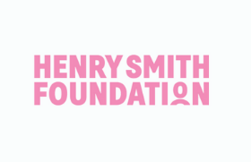
Aims/priorities: | The funding helps to provide opportunities for children aged 13 years or younger who face financial hardship, systemic inequity or disability to go on a short recreational holiday or outing they would not otherwise have the opportunity to experience.
Who can apply? | Schools, youth groups, not-for-profit organisations and charities in the UK are eligible to apply.
Grant amount: | Up to £ 2,800
Application process: | To start the application process, groups need to complete a short eligibility quiz on the Foundation's website. Those who are eligible will then have access to the full online application form.
Deadline: | 19th November 2025
Contact: | 020 7264 4970
Website: | Holiday grants - Henry Smith

Benefact Trust – Community Impact Grants |  | 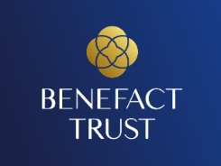
Aims/priorities: | This fund aims to support Christian organisations to deliver projects that will make a positive and transformative impact on lives and communities and contribute to the following objectives:  - Growing congregations and Christian communities.  - Addressing social challenges facing communities.  - Enabling wider community use of church buildings.  - Empowering Christian education.
Who can apply? | Churches, cathedrals, denominational bodies, Christian charities, schools, and theological educational institutions with a clear Christian ethos can apply.
Grant amount: | Discretionary
Application process: | Applications can be submitted at any time.  Guidance notes and an online application form are available from the Benefact Trust website.
Deadline: | Rolling Programme
Contact: | info@benefacttrust.co.uk
Website: | Community Impact Grants | Community Grants & Funding

DIGITAL
The Access Foundation- Digital Divide |  | 
Aims/priorities: | The Access Foundation awards grants to support charities and CICs to mitigate the digital divide by making IT facilities, support and learning available to disadvantaged and vulnerable people.
Who can apply? | Applications may only be made by bona fide charities, not for profit organisations (including Community Interest Companies (“CICs”) that are limited by guarantee but excluding CICs limited by shares), but not individuals.
Grant amount: | Grants between £10,000 and £50,000
Application process: | There is an online application form.
Deadline: | Applications are accepted on a rolling basis.
Contact: | office@theaccessgroupfoundation.com
Website: | https://theaccessgroupfoundation.com/apply/

ENVIRONMENT
National Lottery Awards for All England – Environment |  | 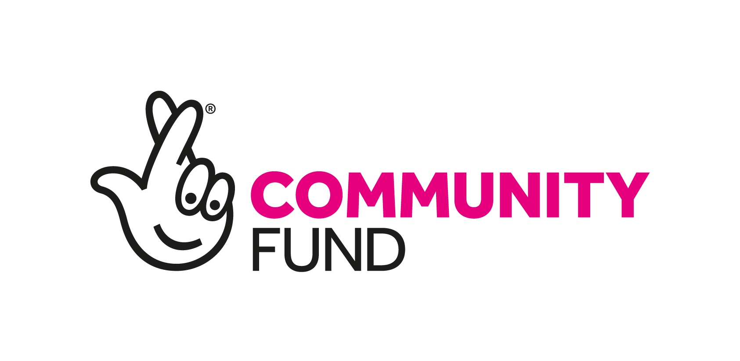
Aims/priorities: | The funding is for projects that meet one or both of these aims:  - Help people connect with and care for nature in their area.  - Make a positive difference to the environment.
Who can apply? | Applications are accepted from:  - Constituted voluntary or community organisations  - Constituted groups or clubs  - Registered charities  - Charitable incorporated organisations (CIOs)  - Not-for-profit companies  - Community interest company (CICs)  - Schools, if the project helps the local community, not just the school  - Statutory bodies (including local authorities, town, parish, and community councils)  - Community benefit societies.
Grant amount: | Up to £ 20,000,000
Application process: | Guidance notes and the online application form are available on the NLCF website.
Deadline: | 17th of December 2025
Contact: | General.Enquiries@tnlcommunityfund.org.uk
Website: | National Lottery Awards for All England – Environment | The National Lottery Community Fund

Tree Council - Branching Out Fund |  | 
Aims/priorities: | The funding is for tree and hedge planting projects taking place during the 2025/26 winter planting season.
Who can apply? | Funding can be awarded to:  - Schools.  - Further education colleges and universities.  - Constituted community groups.  - Childcare nurseries or care homes (charity or community funded).  - Tenants and residents associations.  - Parish/town councils/community councils.  - Tree Warden networks (preference will be given to a Tree Council member network).  - Community interest companies (limited by guarantee).  - Small registered charities.
Grant amount: | Up to £ 2,500
Application process: | Guidance notes and an online application form are available from the Tree Council website.
Deadline: | 14th November 2025
Contact: | geraldine.creaven@treecouncil.org.uk
Website: | Grant funding to support tree, hedgerow and orchard establishment

International Tree Foundation - UK Community Tree Planting Programme |  | 
Aims/priorities: | The UK Community Tree Planting Programme supports projects run by community groups and voluntary organisations that engage communities in planting and caring for native species of trees.
Who can apply? | Community-based organisations, such as a school, community group, social enterprise, non-governmental organisation, or parish council, can apply.
Grant amount: | Discretionary
Application process: | There is a two-stage application process:  - Groups must first submit an online Expression of Interest form which will be assessed within one month of the date of submission.  - Successful applicants will then be short-listed to complete a full application.  Guidance notes are available from the International Tree Foundation's website.
Deadline: | 12th December 2025.
Contact: | programmes@internationaltreefoundation.org
Website: | International Tree Foundation

FAITH
National Lottery Heritage Fund: Strategic Initiatives – Heritage in Need: Places of Worship |  | 
Aims/priorities: | This fund aims to address the following challenges facing places of worship:  - The repair needs of listed buildings, particularly those in more rural areas.  - Workforce and volunteer capability to manage heritage.  - Supporting heritage in places of worship that are currently inaccessible, at risk, or under-used, to maximise their full potential.
Who can apply? | Not-for-profit organisations and partnerships led by not-for-profit organisations from across the UK can apply.
Grant amount: | Up to £ 10,000,000
Application process: | Groups must first submit an online Expression of Interest.  Successful groups will then be invited to submit a full application.
Deadline: | 12th November 2025
Contact: | enquire@heritagefund.org.uk
Website: | Strategic initiatives | The National Lottery Heritage Fund

Congregational and General Charitable Trust Grants |  | 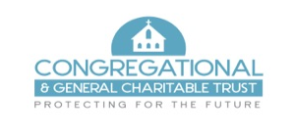
Aims/priorities: | The Trust's objectives are:  - To make grants for the overall care, upkeep and extension of churches  - To make grants towards the capital costs of church community projects  - To promote the Christian religion and, in particular, the United Reformed and Congregational denominations, and other churches of the Protestant tradition.  We are also able to consider applications from church community projects for funding towards capital costs (but not for ongoing work).  Grants approved will normally be for capital projects involving building work such as repairs, improvements or extensions.
Who can apply? | Applications are accepted from all churches of the Protestant tradition in the UK, but particularly those of the United Reformed and Congregational denominations.
Grant amount: | Up to £25,000
Application process: | An application form can be downloaded via the website which must be returned via email.
Deadline: | 24 October 2025 - 10:00 AM
Contact: | admin@candgtrust.org.uk
Website: | https://www.candgtrust.org.uk/apply

GENERAL
National Lottery Community Fund - Climate Action Fund - Our Shared Future
Aims/priorities: | The funding is for formal partnership working across sectors, led by community and voluntary organisations or public sector organisations for projects that reach more people by either:  - Influencing communities at a regional, national or UK level, for example by linking larger campaigns or projects that will inspire people to take action on climate issues, or helping communities to influence the people that make policies that affect them.  - Linking climate action to the everyday lives and interests of local communities and using people's day-to-day activities to inspire them to do things differently and work towards lasting impact.
Who can apply? | To get funding, a partner organisation must be a:  - Constituted voluntary or community organisation.  - Registered charity.  - Charitable incorporated organisation (CIO or SCIO).  - Not-for-profit company limited by guarantee that is a registered charity or has a not-for-profit ‘asset lock’ clause in their articles of association.  - Community Interest Company (CIC).  - School, college, university (as long as their project benefits and involves the wider local communities).  - Statutory body (including local authorities, town, parish or community councils).  - Community benefit society.  - Co-operative society with a not-for-profit ‘asset lock’ clause in their society rules and also be registered with the Financial Conduct Authority.
Grant amount: | Up to £ 1,500,000
Application process: | Full guidance and the online application form can be found on the NLCF website.
Deadline: | 17th December 2025
Contact: | general.enquiries@tnlcommunityfund.org.uk
Website: | Climate Action Fund - Our Shared Future | The National Lottery Community Fund

B&Q Foundation Grants |  | 
Aims/priorities: | The funding is intended for registered charities working with people in need (by reason of financial hardship, sickness, disability, other disadvantage or distress) in the UK and who need funding for the following:  - Projects that provide, maintain, repair or improve housing or community space  - Supporting people experiencing poor housing or homelessness
Who can apply? | UK registered charities based and working in the UK can apply.
Grant amount: | There are two levels of grants:  - Up to £5,000 for garden projects  - Up to £10,000 for building or indoor projects
Application process: | There is an online application process.  Please note groups will need to create a profile on the Neighbourly platform as part of the B&Q Foundation application process. The profile can also be used to access other types of support on the Neighbourly platform.
Deadline: | The next round opens on 20 October and closes on 7 November 2025
Contact: | Email: bandq@neighbourly.com
Website: | https://bqfoundation.org.uk/apply-for-a-grant/

Fitton Trust
Aims/priorities: | The aim of the charity are to benefit by way of grants such legally charitable institutions as the trustees shall in their absolute discretion think fit.
Who can apply? | UK registered charitable organisations in the UK can apply.
Grant amount: | Up to £ 350
Application process: | The Trust does not have a website or publish any contact details other than the postal address.  The Trustees meet three times a year (usually in April, August and December) to consider applications.  Groups should write to the Fitton Trust for further information on how to apply and any restrictions to the funding.
Deadline: | The Trustees meet three times a year (usually in April, August and December) to consider applications.
Contact: | Fitton Trust  Po Box 289  Bramhall  Stockport  SK7 0DZ
Website: | N/A

HEALTH & WELLBEING
Baily Thomas Charitable Fund |  | 
Aims/priorities: | The funding is available for projects that aid the care and relief of those affected by learning disability. The Baily Thomas Charitable Fund describes people with learning disabilities as having three things:  - Global intellectual impairment (intelligence quotient less than 70)  - Need for support/help to fulfil ordinary daily activities  - Onset before the age of 18 years.
Who can apply? | Applications will only be considered from voluntary organisations which are registered charities or are associated with a registered charity. Exempt charities such as schools, Parent Teacher Associations and Industrial & Provident Societies can also apply.
Grant amount: | Discretionary
Application process: | Application forms are available to complete online at the Fund's website.
Deadline: | 1st December 2025.
Contact: | info@bailythomas.org.uk
Website: | General guidelines | Baily Thomas Charitable Fund

Motability Foundation - Better Access to Active Travel Experiences and Equipment |  | 
Aims/priorities: | The funding is intended to develop, expand and improve active travel options for disabled people.
Who can apply? | Applications will be accepted from the following:  - Incorporated Charity  - Company Limited by Guarantee  - Community Interest Company (CIC)  - Community Benefit Society
Grant amount: | Up to £ 1,000,000 over a period of up to three years.
Application process: | There is a two-stage application process:  - Stage One - the first step is to submit an online Expression of Interest (EoI) form. Decisions can be expected within four to six weeks.  - Stage Two - those with a successful EoI will be invited to submit a full application form.  Full guidelines and the Stage One application form can be found on the Motability Foundation website.
Deadline: | 15th December 2025.
Contact: | GrantstoOrganisations@motabilityfoundation.org.uk
Website: | Better Access to Active Travel Experiences and Equipment | Organisation grants

Forces in Mind Trust |  | 
Aims/priorities: | The funding is intended to support vulnerable ex-serving members of the Armed Forces and their families in their transition to civilian life in the UK. It funds work across seven interconnecting outcome areas:  - Housing  - Employment  - Health  - Finance  - Criminal justice  - Relationships  - Enabler
Who can apply? | Not-for-profit organisations – from small groups and charities to larger institutions such as universities – working for the benefit of ex-Service men or women and their families can apply.
Grant amount: | Discretionary
Application process: | There is a two-stage application process:  - Applicants must first submit an initial enquiry using the online form on the FiMT website. This should include a cover letter and a project outline, which must be uploaded as separate documents.  - Organisations whose application meet the Trust’s current objectives and priorities will be asked to complete a full application.
Deadline: | N/A
Contact: | Forces in Mind Trust - Supporting Ex-Service Personnel
Website: | enquiries@fim-trust.org

HERITAGE
National Archives - Seed Corn Grants |  | 
Aims/priorities: | The funding is intended to support early-stage, exploratory projects that aim to spark new ideas and innovative approaches to community engagement with heritage. The grants are particularly designed to help organisations test concepts, build partnerships, or pilot activities, with a strong emphasis on experimentation and learning.
Who can apply? | Eligible applicants include community groups and GLAM (Galleries, Libraries, Archives, and Museums) and other heritage organisations working with communities across the UK.
Grant amount: | Up to £ 5,000
Application process: | Contact the National Archives for further information.
Deadline: | 28th November 2025.
Contact: | sophie.ansteedemas@nationalarchives.gov.uk
Website: | Seed Corn Grants - Portals

National Lottery Heritage Fund: Strategic Initiatives – Landscape Connections |  | 
Aims/priorities: | This fund aims to support and strengthen protected and world-class landscapes to become better for nature and provide space for people to relax and connect with the environment.
Who can apply? | Not-for-profit organisations and partnerships led by not-for-profit organisations can apply.
Grant amount: | Up to £ 10,000,000
Application process: | Groups must first submit an online Expression of Interest.  Successful groups will then be invited to submit a full application.
Deadline: | 12th November 2025.
Contact: | enquire@heritagefund.org.uk
Website: | Strategic initiatives | The National Lottery Heritage Fund

Swire Charitable Trust |  | 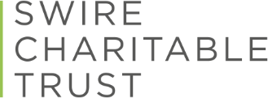
Aims/priorities: | The funding is for UK charities supporting some of the UK’s most vulnerable people to overcome barriers and realise their potential, and to charities who are protecting the UK’s environment and heritage.
Who can apply? | UK registered charities can apply.  Priority will be given to charities that:  - Operate in some of the most disadvantaged parts of the UK.  - Try to engage the most marginalised and vulnerable in their work.  - Can clearly demonstrate the needs they are addressing.  - Know what they are aiming to achieve and plan to monitor and evaluate outcomes.  - Are well placed and well qualified to deliver the work.  - Can show a proven track record as well as solid ambitions.  - Have the potential to change the way issues are tackled more widely.  - Take an effective approach to using volunteers and mentors (where appropriate).  - Are seeking to make their income streams more sustainable.  - Have strong and quality leadership.  - Manage their finances prudently.
Grant amount: | Discretionary
Application process: | There is a one-stage application process, with a single online form for all grants.  The Trust runs a rolling programme with regular grant making meetings, so there are no deadlines for submission. Once an application has been submitted it will be assigned to the next available meeting. Applicants can expect to receive an outcome within two to three months of submission, but occasionally it can take slightly longer.  The application guidelines, application form questions, standard grant conditions, frequently asked questions and online application form can be found on the Swire Charitable Trust website. Applications submitted by email or post will not be considered.  Applicants that are unsuccessful must wait at least one year before reapplying.  Contact the Swire Charitable Trust for further information.
Deadline: | Rolling Programme
Contact: | info@scts.org.uk
Website: | Welcome - The Swire Charitable Trust

OLDER PEOPLE
Barchester Healthcare Foundation |  | 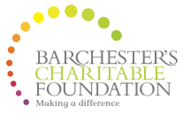
Aims/priorities: | The Foundation aims to make a difference to the lives of older people and other adults with a physical, learning or mental disability; supporting practical solutions that lead to increased personal independence, self-sufficiency and dignity.  The aim of this fund is on connecting or re-connecting people with others in their local community. Applications that combat loneliness and enable people to be active and engaged will receive highest priority.
Who can apply? | Although most funding is awarded to individuals, small community groups and small local charities based in England, Scotland or Wales can also apply.  Eligible organisations must provide a breakdown of their budget and their latest annual accounts.
Grant amount: | Up to £ 2,500
Application process: | Applications may be submitted at any time.  Guidance and an online application form are available from the Barchester Healthcare Foundation website.
Deadline: | Rolling Programme
Contact: | info@bhcfoundation.org.uk
Website: | Homepage | Barchester Charitable Foundation

Manchester Guardian Society Charitable Trust
Aims/priorities: | The funding is intended for a wide range of charities and other community organisations which provide charitable benefits for communities within Greater Manchester.
Who can apply? | Registered charities and other community organisations which provide charitable benefits for communities within Greater Manchester can apply.
Grant amount: | Up to £ 3,500
Application process: | Applications can be made at any time.  Guidance notes, trustee meeting dates and deadlines, and an online application form can be found on the Trust's website.  Contact the Manchester Guardian Society Charitable Trust for further information.
Deadline: | Rolling Programme
Contact: | grants@manchesterguardiansociety.org.uk
Website: | Manchester Guardian Society

Robert McAlpine Foundation |  | 
Aims/priorities: | The scheme is intended to support projects in the following areas:  - Children  - The youth  - The elderly  - Social and medical research.
Who can apply? | Eligible organisations must meet the following requirements:  - Be a registered charity.  - Have an annual income of less than £1 million.  - Operate in the UK
Grant amount: | Up to £ 10,000
Application process: | The Trustees meet annually in November to approve grants. An application must be received no later than 31 August in order for it to be considered for inclusion in the next meeting.  Applications should consist of a maximum of two A4 pages outlining:  - Who the charity is  - Charity number  - What work the charity does  - Details of the specific project for which applicants require funding  - The amount of funding applicants are looking for  - Contact details, together with website address if there is one.  Applications must be submitted either by post or email.  Contact Robert McAlpine Foundation for further information.
Deadline: | Rolling Programme
Contact: | foundation@srm.com
Website: | Home | mcalpine-foundation

SPORT & RECREATION
Cash4Clubs |  | 
Aims/priorities: | The 2025 programme is focused on supporting adult participation in sport. Funding is available to groups that support over 18s only.
Who can apply? | Applications are accepted from not-for-profit organisations, including charities, community groups and traditional sports clubs.
Grant amount: | Up to £ 2,000
Application process: | The guidelines and information on the application process are available on the Cash4Clubs website.
Deadline: | 8th December 2025
Contact: | grants@sported.org.uk
Website: | Home - Cash4Clubs

England and Wales Cricket Board - County Grants Fund |  | 
Aims/priorities: | The funding is intended to support projects and activities that may include:  - Creating welcoming environments or actively involved with women’s and girls’ competitive cricket and / or disability cricket.  - Enhanced facilities and playing opportunities for women's and girls' cricket and/or disability  - Tackling climate change (supported by Sport England)
Who can apply? | Cricket clubs in England and Wales that are affiliated to the ECB via their County Cricket Board (CCB) may apply.
Grant amount: | Up to £ 10,000
Application process: | Guidance notes and the online application portal can be accessed from the England and Wales Cricket Board website.
Deadline: | 30th November 2025.
Contact: | grantmanagement@ecb.co.uk
Website: | England and Wales Cricket Board (ECB) - The Official Website of the ECB

Andy Fanshawe Memorial Trust |  | 
Aims/priorities: | The Trust offers funding to support disadvantaged young people to further develop an existing interest in adventurous outdoor activities such as walking, climbing, cycling, kayaking, sailing, horse riding in the UK. The Trust usually supports individuals or small groups.
Who can apply? | Applications are accepted from individual young people or small groups or from organisations, such as schools or youth clubs, on behalf of a young person for self-planned activities or residential courses at an outdoor centre in the UK. To be eligible, individual applicants must provide a reference from a teacher or care worker.
Grant amount: | Discretionary
Application process: | Applications can be made at any time and should be submitted via email in no more than 1,000 words.  Applications should include the following:  - Who is applying?  - What does the project propose to do, and where and when?  - Who will benefit? Why do they deserve the Trust's support?  - What experience does the applicant have of the activity so far?  - How will the funding help the applicant develop their interest further?  - What are the applicant's plans for continuing to progress their interest?  - What fundraising is being done or is planned?  - What is the overall budget?  - How much is being applied for?
Deadline: | Rolling Programme
Contact: | kalisang98@outlook.com
Website: | Andy Fanshawe Memorial Trust - Home

This funding bulletin is produced by
10GM is a joint venture to support the voluntary, community and social enterprise (VCSE) sector in Greater Manchester. The founding members are: Action Together, Bolton CVS, Macc and Salford CVS. For further information regarding 10GM please email: info@10GM.org.uk
Bolton CVS (Community and Voluntary Services)
The Hub, Bold Street, Bolton, BL1 1LS
Tel: 01204 546 010
Email: funding@boltoncvs.org.uk
Website: www.boltoncvs.org.uk

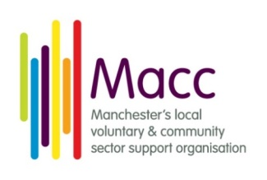 | Manchester Community Central  St Thomas Centre, Ardwick Green North, Manchester, M12 6FZ  Tel: 0333 321 3021  Email: info@mcrcommunitycentral.org  Website: www.manchestercommunitycentral.org
 | Salford CVS  The Old Town Hall, 5 Irwell Place, Salford, M30 0FN  Tel: 0161 787 7795  Email: AnneMarie.Marshall@salfordcvs.co.uk  Website: www.salfordcvs.co.uk

