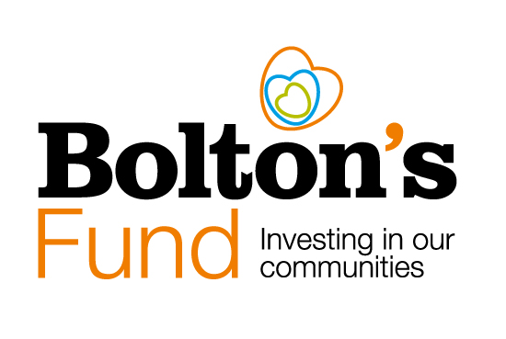\sdf

**Household Support Fund 7 Grants: May 2025 – March 2026**

**Data Collection Requirements for Awardees**

**Important - Data Collection Requirements**

* Successful applicants should state in their application how they will ensure they provide support to the households in the most need of additional support in their community.
* To satisfy the requirements of DWP, organisations receiving a grant will need to have procedures in place to collect and produce information in relation to household composition and the category of support that is given.
* There are three important data collection deadlines for the HSF 7 grants:
  + First set of monitoring data – **by Friday 10th October 2025.**
  + Second set of monitoring data – **by Friday 9th January 2026.**
  + Final set of monitoring data, outcomes report and case studies – by **Friday 10th April 2026.**
* Data collection excel spreadsheets will be sent to all successful applicants. Organisations will be required to gather and report data on spend; volumes and number of households supported in the following categories:
* **The spend and volume of households** you have supported by composition: households with children, households with pensioners, households with disabled person, other households.
* **The spend, and volume of crisis support** **awards split by category:** energy and water, wider essentials, housing costs, food (excluding Free School Meals (FSM) in the holidays) and other types of crisis support.
* **The spend and volume of preventative support awards by category**: advice services, skills, community infrastructure/support, energy efficiency and other types of preventative support.
* You will also need to submit impact information in line with Bolton’s Fund requirements, such as the number of volunteers involved in your HSF project and details of the expenditure on your project.

**In your application, please outline how you will collect this information.**

**All successful applicants will be invited to a briefing session in regard to the collection and return of the data spreadsheets.**

**Support and Further Information from Bolton CVS**

If you would like to chat about a potential application or need help with the application form, please contact us on:

01204 546 010 or email [funding@boltoncvs.org.uk](mailto:funding@boltoncvs.org.uk).

You can also refer to the funding information pages on the Bolton CVS website: <https://www.boltoncvs.org.uk/funding>

**Bolton Community and Voluntary Services (CVS)**

**Registered Charity No: 1003123**

**Registered Company No: 2615057**

The Bolton Hub

Bold Street

Bolton

Greater Manchester

BL1 1LS

01204 546 010

[info@boltoncvs.org.uk](mailto:info@boltoncvs.org.uk)

www.boltoncvs.org.uk