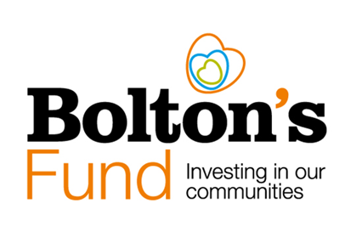

**Household Support Fund 7 (HSF 7) – Large Grants**

**Summary Sheet**

**Summary Sheet**

**Large Grants of up to £40,000 are available for Voluntary, Community and Social Enterprise (VCSE) organisations to support vulnerable low-income households in need, with the cost of living.**

The grants are to be used to help vulnerable low-income households with crisis and / or preventative support.

**Projects must achieve at least one of the following priorities to receive HSF 7 funding:**

1. Provision of crisis support to low-income households
2. Provision of preventative support to low-income households.

**Who Can Apply?**

Community groups, charities and organisations with **an income of over £30,000 in the last full financial year** are eligible to apply for a grant from the **HSF7 Large Grants** fund. Your group or organisation must be based in and/or provide benefit to the people living in the Metropolitan borough of Bolton.

**What can the funding be used for?**

This funding may be used for crisis support and preventative support for vulnerable low-income households in need of additional support who are struggling with essential cost of living costs. A maximum of 20% of the grant can be used to fund the running costs of your HSF 7 project. Please see the HSF 7 Guidelines for more details.

**Who are the target households for support?**

Priority households for funding include vulnerable low-income households in need including:

* Households with disabled people,
* Households with children of all ages,
* Households with pensioners,
* Households with unpaid carers,
* Households with care leavers,
* Larger families,
* Single-person households,
* Those struggling with one-off financial shocks or unforeseen events.

**How long do I have to deliver the project?**

The funding period ends on 31st March 2026. All funds must be committed or spent by this date.

**When is the closing date for applications?**

Applications must be submitted by midnight on Monday 26th May 2025.

**Are there any monitoring or data collection requirements?**

Yes, there are specific data collection requirements for organisations who have been awarded an HSF 7 grant. Please refer to the Household Support Fund 7 – Monitoring Requirements document for details.

**How do I apply?**

**Bolton’s Fund—Investing in our Communities**

Bolton’s Fund—Investing in our Communities

Applications are made through the [Bolton CVS website](http://www.boltoncvs.org.uk/). You will need to create a login and complete an Organisation Registration form before being able to access the Grants Dashboard (where you will find links to the application forms).

**What size grant can I apply for?**

The **maximum grant size is £40,000**. Please apply for the appropriate amount your organisation has the capacity and resources to effectively distribute within the timeframe of the grant (by the end of March 2026).

**How often can I apply to Bolton’s Fund HSF 7 – Large Grants?**

Organisations that are eligible (they must have an income over £30,000 in the last year) can apply for one grant from the Bolton’s Fund HSF7 Large fund. Organisations with an income over £30,000 are not eligible to apply for a Bolton’s Fund HSF 7 – Small Grant.

**How long will it take to find out if my application has been successful?**

We are aiming to get decisions out to applicants as soon as possible after the closing date. Our aim is to let applicants know within 4 weeks of the closing date, but this will depend on the volume of application we receive.

**Further Information and Support**

Find out more about Bolton’s Fund on our website:

**This factsheet is for guidance only. For any further information, guidance and support, please contact Bolton CVS on: 01204 546010 or e-mail: info@boltoncvs.org.uk**

<https://www.boltoncvs.org.uk/>

If you would like a chat about a potential application or you need help with the application form, please contact us on:

01204 546024 or email [funding@boltoncvs.org.uk](mailto:funding@boltoncvs.org.uk)

**Important - Please read the full Guidelines – Household Support Fund 7 and the Household Support Fund 7 - Monitoring Requirements documents on our website before submitting your application.**