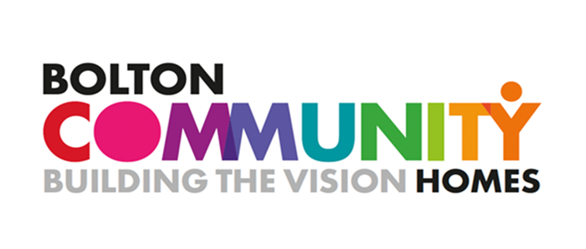
Bolton Community Homes
Community Investment Grants 2023

Information and Guidelines

Grants to Organisations – up to £1000
Micro-grants to Individuals – up to £100

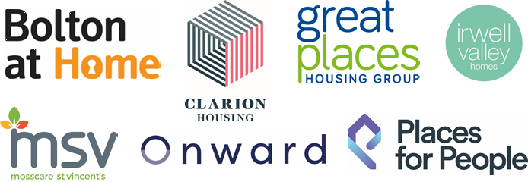
Background

Bolton CVS is working with the Bolton Community Homes (BCH) partnership to deliver their Community Investment Grants.
Charities, community groups, organisations and individuals are invited to apply for grants to help support projects that will benefit BCH customers.
Grants of up to £1000 for organisations and micro-grants of up to £100 for individuals are available.

BCH customers are tenants of properties managed by the following Registered Social Landlords:

- Clarion Housing Group
- Onward
- Great Places
- Irwell Valley
- Places for People
- Mosscare St Vincents
- Bolton at Home

Level of Grant Available

Applicant | Level of Grant | How to Apply
Organisations | Grants of up to £1000 | Through Bolton CVS website
Micro-grants for Individuals | Grants of up to £100 | Please complete Word application form and email to: funding@boltoncvs.org.uk

What We Will Fund – Grants to Organisations and Individuals

The fund aims to support projects and delivery by organisations and individuals that make a difference in the lives of BCH tenants and their local communities.
Funding can help you in many ways, for example, to buy new equipment or materials, to run a community event, to launch a new group or to help promote existing groups locally.
Up to 50% of your grant award can be used as a contribution towards the core running costs of your organisation (this includes operating costs relating to energy, fuel, rent, food, services, volunteer expenses, paying staff a living wage).
Your project must help people in at least one of the following ways:
Health and Wellbeing – improving residents’ (and older people’s) health and wellbeing – for example, dance classes to improve fitness.
Children and Young People – increasing the opportunities/activities available for young people - for example, running a youth group.
Cost of Living Support – supporting people to relieve financial pressures and reduce poverty - for example, a sewing group helping with school uniforms.
Training and Employment Skills – delivering training – for example, digital skills training, jobs clubs or courses.
Connecting Communities – to help make the community stronger and to encourage communities to come together. For example, organising a community fun day.
Environment – improving the environment. This could be through carbon reduction measures or through local action such as helping to maintain gardens and communal areas or organising a clean-up.
We will score your application based on how well your project will contribute to these themes.
You only need to meet one of these themes. In fact, it is better to meet one theme very well rather than all of them loosely.
If you are unsure which theme your project fits, please refer to contact details at the end of the document.
Grants to Organisations

There is a £1000 limit for BCH Community Investment Grants but we expect community groups to apply for the real costs rather than the maximum grant available.
Your group can receive a maximum of one BCH Investment during each financial year (April to end of following March).
Eligibility for Organisations
To be eligible to apply for a Bolton Community Homes grant, your group or organisation must have had an income of less than £100,000 per annum in the last full financial year and be:
- A constituted voluntary or community group*
- A registered charity
- Another type of constituted not for profit organisation.

Other eligibility factors include:

- Your group or organisation must be based and/or provide benefit to people living in the Metropolitan Borough of Bolton (Bolton Council’s local authority area).
- You must have a bank account in the name of the group (not an individual) with at least two signatories.
- Organisations must be up to date with the monitoring returns for any previous grants managed through Bolton CVS**
- A minimum of three committee members or trustees if you are a community group or charity.
- If your costings include payments to a trustee or committee member, your governing document must allow this and you must have appropriate procedures in place to manage any potential conflict of interest.
- We expect you to have appropriate insurance for your groups’ activities.
- If you run sports activities your sports coaches (volunteer or paid) must be registered with Bolton Council’s Register of Sports Coaches or another suitably recognised body.
*For unconstituted groups, please get in touch with the team. We will ask you to tell us who is involved in your project and the name of an organisation that will be able to hold the funding on your behalf, if successful.
**We understand that there can be a variety of reasons why monitoring may be late or incomplete. The Bolton CVS Development Team is here to support organisations who need support with their monitoring. If your organisation has a history of late, incomplete or inadequate monitoring returns, we reserve the right to provide this information to the grant assessors.

These are the minimum standards you must meet to be eligible to apply for funding. If you need help with any of the points below, please do not hesitate to contact the team at Bolton CVS, as we are here to help.

Micro-grants to Individuals

Tenants of the seven listed Registered Social Housing Landlords in the BCH Partnership can apply for grants of up to £100 to fund an idea that will help to improve their community.
Individuals who have an idea that could help their community can apply for a one-off grant of up to £100 to purchase equipment or to help fund an event or activity that will benefit the community.
Individuals can receive a one BCH Investment during each financial year (April to end of following March). A maximum of 25 grants to individuals will be made each financial year.
Eligibility for Individuals
- Individuals applying must be a tenant of one of the seven Registered Social Housing Landlords involved in the BCH partnership.
- The purpose of the micro-grant must be charitable in nature. (See the Gov.uk website for definitions of charitable purposes - https://www.gov.uk/setting-up-charity/charitable-purposes)
- The grants to individuals will fund ideas that will benefit your community – this could be anything from refreshments for a Fun Day to buying something that will bring some joy to your community or to thank people who have undertaken some community action. We would love to hear your idea!
- The individual applying must have their own bank account (in their own name)
- They must be aged 18 years old or over.

Deadlines and how to apply

Deadline for applications – organisations and individuals | Applications will be considered on a rolling basis. This means there is no deadline and the fund will remain open for applications as long as there is remaining funds to distribute.
Applications by organisations | Click here to apply  - The application form needs to be completed online. Please see Bolton CVS Grants and Investments on our website: www.boltoncvs.org.uk for instructions and links to the online application form.  - If you need help completing the online form, Bolton CVS are happy to help you. Please find our contact details on the last page.
Applications by individuals | Please complete the Word application form and email to: funding@boltoncvs.org.uk  Email funding@boltoncvs.org.uk for an application form or contact a member of staff from your Social Housing Landlord.
Notification of outcome | You will be notified within 6 -8 weeks of your application being submitted.  Please do not start your funded project until you have been informed about the outcome of your application.

What we cannot fund – for organisations
- Private companies.
- Projects that do not benefit tenants of one of the BCH partners listed above.
- Grants that include more than a 50% allocation towards utilities including rent, gas, electricity and water bills and maintenance costs (including maintenance equipment).
- Items that only benefit an individual, for example bursaries or kit and equipment that will not be shared.
- Equipment for one off events.
- Grants that include more than a 50% allocation towards salaries for permanent employees (but you can apply for funding for temporary contract/freelance workers, for example artists, sports coaches etc.)
- Activities specifically promoting religious beliefs or political views
- The cost of projects that take place or are paid for before a grant from us is confirmed
- Projects with high ongoing costs or that require specialist skills to maintain.
- General fundraising appeals/ fundraising on behalf of another organisation.
We strongly encourage you to make contact with a member of staff from your local housing provider in Bolton before submitting an application.

What we cannot fund – for individuals

- Items and events that will only benefit one person.
- Activities specifically promoting religious beliefs or political views.
- The cost of projects or activities that take place or are paid for before a grant from us is confirmed.
- Projects with high ongoing costs or that require specialist skills to maintain.
- General fundraising appeals/ fundraising on behalf of another organisation.
- The purchase of alcohol.

Working with children and young people or vulnerable adults

If you are working with children or young people and/or vulnerable adults, your group or organisation needs to have a named committee member or trustee responsible for safeguarding. Your Safeguarding Policy must outline clear steps to take in the event of an incident or disclosure, including who to inform and how to contact them.

If you run sports activities your sports coaches (volunteer or paid) must be registered with Bolton Council’s Register of Sports Coaches or another suitably recognised body.
If you are unsure about this, please get in touch as we can provide assistance and training.

What happens next?

Once we have received your application we will complete initial checks to ensure:
- That you meet our minimum standards for eligibility.
- You or the organisation you are applying on behalf of is eligible to apply for the fund.
- That you have completed all outstanding monitoring for any other applications you have that are managed by Bolton CVS.
- That you have answered all the questions.

If you meet all the above your application is then passed for assessment. Each application will be assessed separately by volunteer trained grant assessors who will score your application according to the set criteria. The total scores are then collated and the decision will then be made.

Information about the Grant assessors:
- Assessors are individuals from BCH partners, community volunteers and/or representatives of Bolton-based voluntary and community groups and organisations.
- Assessors regularly change – we do not have the same assessors each year or for each assessment round.
- All assessors are volunteers and volunteer their time free of charge.
- All assessors are provided with training and support from Bolton CVS.
- No Bolton CVS staff, volunteers or trustees are involved in panel decision making.
- We do not invite elected members of Bolton Council or those standing for election to assess funding applications.
- Conflicts of interest are managed through an open and transparent ‘declaration of interest’ process. Conflicts of interest are recorded when appointed as an assessor and at each panel meeting.

Fundraising with Easyfundraising

Bolton CVS is now working in partnership with the funding website easyfundraising to enable groups to access a new unrestricted funding source.
Offering an easy, continuous, and accessible fundraising option, easyfundraising enables organisations to raise money to support themselves and the wider community through online shopping. Leading online retailers including Sainsbury’s, eBay, Tesco, M&S, Asda, Argos, Just Eat, Morrisons, Trainline, booking.com and 7,000 others will donate a percentage of what someone spends with them to your organisation - for free.
Sign up here: https://www.easyfundraising.org.uk/bolton/

Our contact details

If you need help with the application form, please contact Bolton CVS
T: 01204 546 010. Funding@boltoncvs.org.uk.

Bolton Community and Voluntary Services (CVS)
Registered Charity No: 1003123
Registered Company No: 2615057
The Bolton Hub
Bold Street
Bolton
Greater Manchester
BL1 1LS
01204 546 010

funding@boltoncvs.org.uk
www.boltoncvs.org.uk

